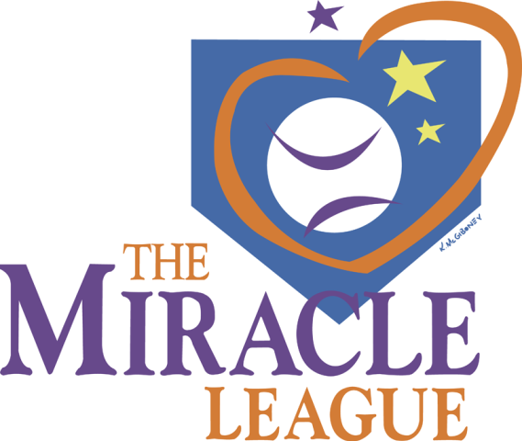Miracle League of Central Minnesota
Registration Form FALL League 2021

Metro Lions Miracle Field at Whitney Park St. Cloud, MN

Complete one form per player $45 registration fee per player
***If you play both days, the fees are $80
Registration Deadline: NO later than Wednesday June 30th 2021…

Player name: _________________________________ Age:_______
Address: _________________________________ Phone___________
City: __________________ State: ___________ Zip:_______________
E-Mail: ____________________________________________________
How did you hear about our league?____________________________________

Sign me up for League play on: ____ Sunday ___ Tuesday
(NOTE: You DO NOT pick the time, just the day of the week to play.)
***Opening Day is on your first night of baseball. Closing day is your last night.
Tuesday game times 5:30 & 6:45| August 24th, 31st & September 7th, 14th, 21st **Tuesday League is capped at 44 players**

Sunday game times 4:00 & 5:15| August 22nd, 29th & September 12th, 19th, 26th
Depending on the number of players, a third game may be played at 6:30 for Sunday League.
NO Game on Sunday of Memorial Day Weekend

Please Print | Parent/Guardian | 2nd Contact information
Full Name
Telephone
Email

Emergency Contact & Phone: __________________________________________

I hereby give permission for the above named child to take part in all activities and photos of the Miracle League of Central Minnesota for the current season. I assume all risks and hazards incidental to the conduct of the activities and transportation to and from such. I hereby release, absolve, indemnify and hold harmless Miracle League of Central Minnesota, organizers, sponsors and coaches appointed by them.

Parent/Guardian Signature: ________________________________________ Date:______________
1
Please share with us a little about your player and anything that you think may benefit league organizers to help make this the best possible experience for you/them. Please be specific. ______________________________________
_______________________________________________________________
_______________________________________________________________
_______________________________________________________________
___ Yes ___ No Is your player in a wheelchair, scooter, or uses a gait walker?
(This information is to help us alleviate congestion in the dugout)

Please indicate PLAYERS shirt size Youth S, M, L Adult S, M, L, XL, 2XL, 3XL

- Several times a year, we have Groups that like to come in for a day and Volunteer. On those dates, would you be interested in having one of them Buddy for you? ____ Yes ____ No

Please indicate BUDDY shirt size. Youth S, M, L Adult S, M, L, XL, 2XL, 3XL
**If you are reusing your Buddy shirt from a prior season, check here ___ and you can deduct $5 from your registration.

** Due to logistics, late registrants will not have a jersey.

IMPORTANT NOTE: Any additional information, as well as your complete season schedule will follow the close of registration. Please contact the League Official below with any questions.

PLEASE consider donating your time and/or your Companies time as a COACH or VOLUNTEER!
This is a fantastic Team building experience for our ML kids as well as your Employees!
Contact Jamie if you are willing and able to volunteer this year.

Jamie Mortland, Director of League Operations
Miracleleagueofcentralmn@gmail.com
320-469-0516

PLEASE Submit Forms and Fees by WEDNESDAY June 30th 2021…
Checks payable to: Miracle League of Central Minnesota-Registration
PO Box 1935
St. Cloud, MN 56302

PLEASE make sure you have read the materials carefully and filled in all the requested Information!

Play Ball!
2
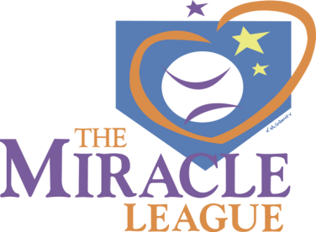
MEDICAL RELEASE FORM

Please read carefully and fill out completely. A Medical Release form must accompany any and all Registrations for each season.

Player/Athlete First Name:_____________________ Last Name:_________________
Date of Birth:_______________________ Child’s Diagnosis: ____________________

Emergency Contact:______________________________________________
Phone:___________________ Relationship:______________________

I understand that a parent/guardian or caregiver familiar with my child’s needs and medical condition must be present at the field for the entire time my child is participating.

The Miracle League of Central Minnesota strongly encourages and requires the use of protective equipment during league play. Protective equipment is supplied by the league for your child’s safety. Your child will be encouraged to use these pieces of equipment by their coaches and league officials during play. Protective equipment cannot prevent all injuries a player may receive while participating but significantly reduces the risk. Your help, compliance and cooperation with this is strongly encouraged and greatly appreciated!

Helmet Waiver: I have been advised of the importance and requirements of wearing
protective equipment such as a batting helmet. I understand that choosing not to have my
child wear this piece of equipment is not in compliance with league rules and
recommendations. By signing this waiver I assume all responsibility for any injury as a
result of not wearing this piece of protective equipment:
Parent/GuardianSignature:_______________________________________________

I _____________________________________ (PRINT parent/guardian’s name) have read the above and give my consent and permission for my child________________________________________ (PRINT child’s name) to participate in the Miracle League of Central Minnesota.

I hereby release, absolve and hold harmless Miracle League of Central Minnesota Organizers, sponsors and coaches appointed by them.

Parent/Guardian Signature: ______________________________________________

3
Guidelines for the Miracle League to play in 2021.

Buddies. To maintain gathering limitations and reduce points of contact, we are requesting family members (12 yrs. old or older) or caregivers to provide support to players. Therefore each player will provide their own Buddy if one is needed. Buddy and player are encouraged to wear a mask.

Spectator. Stands will be roped off on game days. We are required to limit the total number of spectators for our Games (spectator capacity is defined by fixed seating capacity (77) seats x 30% (capacity) = approximately 23 spectators/game). Therefore we are estimating that a maximum of one spectator per player. (Buddies are not spectators). All spectators will be required to wear a mask while at the field. Please bring your own portable chair if possible. If seating capacity calculations change these limits will be adjusted accordingly and communicated to all prior to the game.

Sanitizing. On-site preventative measures will be done to ensure safety. They include washing hands, using hand sanitizer, social distancing and encouraging face masks.

Affirmation. Each week, family members will need to affirm that all household members have not knowingly been exposed to anyone diagnosed with COVID-19 within the past 14 days.

Player-to-player contact. To minimize risk, we will limit player-to-player contact— for example no hugging, end-of-game high-fives, or playing catch in the infield and outfield.

Use of bats. We encourage players to bring a plastic bat with their name on it. However, we will provide bats as we have in the past, and sanitize before the next batter. Please no metal bats this year. If a player brings their own bat they should take it home with them between games.

Use of Helmets. Optional. Should players’ need a batting helmet please bring one from home. Put the player’s name on the helmet and take it home with them between games..

Dugouts. We will not use the dugouts but rather use the field gates on each side (1st base or 3rd base) for the players to enter and leave.

Baseballs. We will rotate through on a regular basis, at least every inning, to limit individual contact. Used balls will be sanitized prior to being put back in play. Only the pitched ball will be in play and no other balls used during the games.

Coach, Catcher and Pitcher. Volunteers are encouraged to keep a safe distance from players and will wear a mask while at the facility.

4
COVID-19 Liability Release Waiver for Miracle League Baseball Programs

Due to the 2020-21 outbreak of the novel Coronavirus (COVID-19), We are taking extra precautions with the care of every player, family member, coaches and volunteers to include health history review and enhanced sanitation/disinfecting procedures in compliance with CDC guidance.

Symptoms of COVID-19 include: Fever/Chills, Headache, Sore throat, Cough, New loss of taste or smell, Fatigue, Shortness of breath or difficulty breathing, Congestion or runny nose, Muscle or body aches, Nausea or vomiting.

• I understand the above symptoms and affirm that I, as well as all household members, do not currently have, nor have experienced the symptoms listed above within the last 14 days.
• I affirm that I, as well as all household members, have not been diagnosed with COVID-19 within the past 30 days.
• I affirm that I, as well as all household members, have not knowingly been exposed to anyone diagnosed with COVID-19 within the past 30 days.
• I affirm that I, as well as all household members, have not traveled outside of the country or to any city considered to be a “hot spot” for COVID-19 infections within the past 30-days.
• I understand that The Miracle League cannot be held liable for any exposure to the COVID-19 virus caused by misinformation on this form or the health history provided by each participant.
• We are following theses enhanced procedures to prevent the spread of COVID-19: In order to protect each player, family members, coaches and all volunteers.

o Taking Temperatures before entering complex
o Washing Hands
o Using Hand Sanitizer enhancing protection
o Social distancing
o Encouraging face masks

• By signing below, I agree to each statement above and release The Miracle League from all liability for unintentional exposure or harm due to COVID-19.

Please print player name: _____________________________________________________

Please print Parent/Guardian name: ____________________________________________

Parent/Guardian signature:_________________________________________ Date:_____________

5

